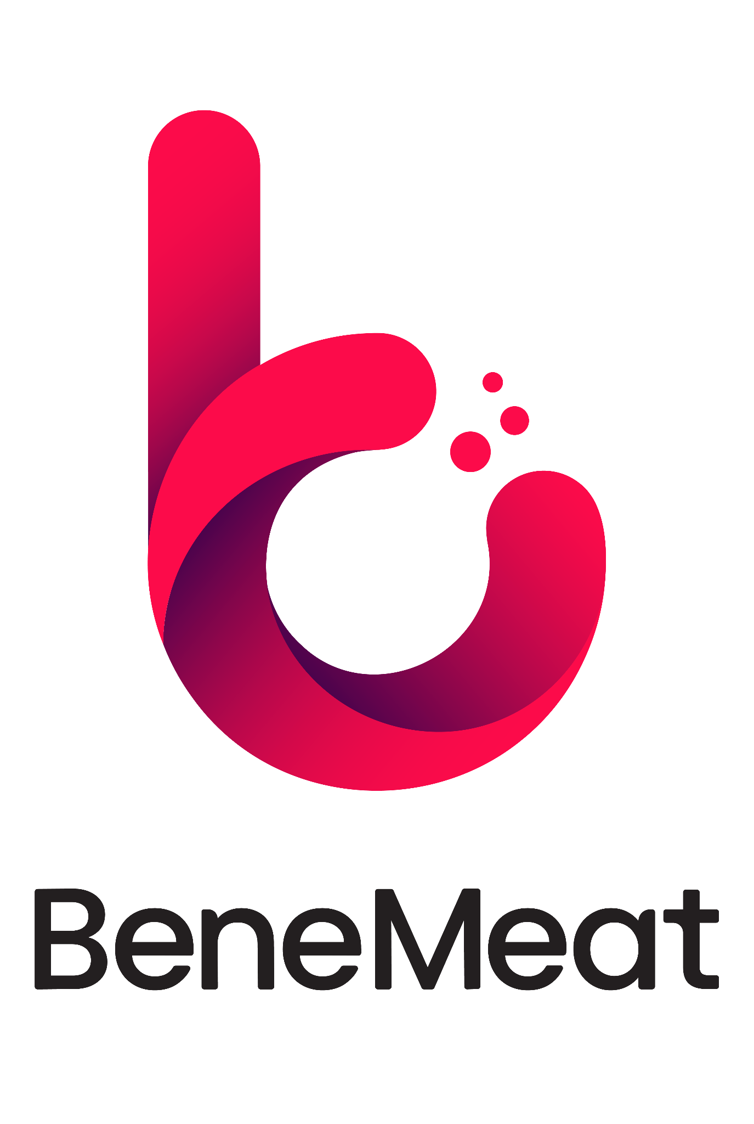

Dialogue Instead of Prejudice: BeneMeat Welcomes Representatives of the Czech Meat Processors Association

Open dialogue is the foundation of every technological transformation. With this objective in mind, BeneMeat welcomed representatives of the Czech Meat Processors Association (ČSZM) to showcase its pilot production facility and cultivated meat manufacturing technology. The meeting confirmed a shared commitment to fact-based discussion, mutual understanding, and exploring future opportunities.
In June, BeneMeat hosted representatives of the Czech Meat Processors Association, led by Chairman Ing. Jaromír Kloud and Executive Director MVDr. Radek Slanec. During the visit, guests toured the company's pilot production facility and met with BeneMeat experts to discuss cultivated cell technology, its potential future applications, and the regulatory framework surrounding cultivated meat products.
For BeneMeat, the meeting represents an important milestone. The company considers open dialogue with the conventional meat industry an essential part of the responsible development of the entire sector.
"We do not see cultivated cells as competition to conventional meat production, but rather as its natural complement. Our goal is to provide an additional technological option that can help expand the traditional product portfolio in the future. That is why we consider open dialogue with the entire meat industry absolutely essential. We greatly appreciate the opportunity to welcome representatives of the Czech Meat Processors Association to our facilities, and we believe this meeting marks the beginning of long-term cooperation built on professional discussion, knowledge sharing, and mutual understanding. We would also welcome similar dialogue between other cultivated meat companies and the conventional meat sector," says Roman Kříž, CEO of BeneMeat.
The visit included a guided tour of BeneMeat's pilot production facility led by Radovan Čadek, Director of Production at BeneMeat. Guests had the opportunity to gain first-hand insight into every stage of the manufacturing process as well as the technological solutions BeneMeat is developing for future industrial-scale production.
"We greatly appreciate the opportunity to present our technology to professionals who have dedicated their careers to the meat industry. The best way to answer questions and address concerns is to show the technology first-hand and openly discuss every aspect of the production process," says Radovan Čadek, Director of Production at BeneMeat.
According to BeneMeat, the scale of its pilot production module clearly demonstrates how far the cultivated meat industry has progressed. Today's facilities no longer resemble small laboratory experiments but represent industrial technology designed for further scale-up and commercialization.
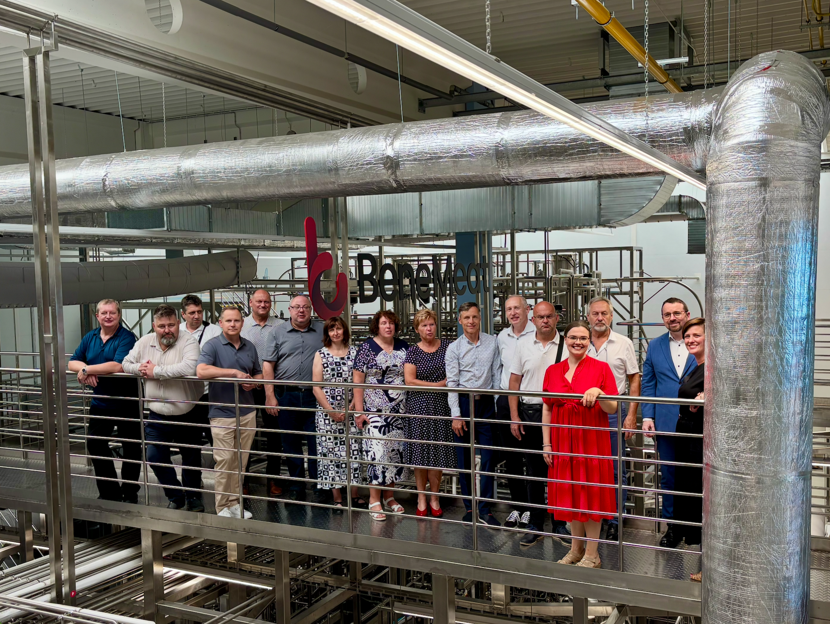
The scale of the production module is also clearly visible in the accompanying group photograph.
A significant part of the meeting focused on product labelling. BeneMeat has long advocated for clear and transparent communication with consumers that both supports public understanding and facilitates product acceptance while complying fully with existing regulatory requirements.
"For the general public, the term cultivated meat is the clearest way to describe both the technology and the final product. On BeneMeat products, however, we use the designation cultivated cells together with the origin of the cells, fully in line with current legislation and regulatory requirements," explains Marek Širl, BeneMeat.
"Europe has world-class scientists, outstanding research capabilities, and cutting-edge technologies. However, maintaining this leadership position requires not only evidence-based discussion but also an environment that genuinely supports innovation. While countries such as the United States and China recognize modern biotechnology as a strategic priority and actively support its development, Europe continues to move much more slowly. If we want to remain globally competitive, we must begin acting accordingly. In line with our Ethical Codex, BeneMeat has chosen not to rely on public funding for its own development. At the same time, we believe future support programs should exist for companies willing to implement these technologies and invest in bringing them into industrial practice," says Roman Kříž, CEO of BeneMeat.
BeneMeat views the visit of the Czech Meat Processors Association as the beginning of a long-term dialogue between developers of emerging food technologies and the conventional meat industry. The company believes that meetings like this help build mutual understanding and create opportunities for future cooperation across the entire sector.
"We would like to thank BeneMeat for the invitation and the opportunity to experience its pilot production facility and cultivated cell technology first-hand. We highly appreciated the open and constructive discussion that truly reflected the spirit of dialogue instead of prejudice. We believe that only professional debate based on verified facts, mutual respect, and transparency can provide an objective assessment of new technologies and their potential role in the future of food production. The Czech Meat Processors Association will continue supporting open communication between representatives of the conventional meat industry, academia, and innovative technology companies," says MVDr. Radek Slanec, Executive Director of the Czech Meat Processors Association.

Cultivated meat
Cultivated meat, also known as cultured meat or cell-based meat, is real animal meat produced by directly growing animal cells in a controlled environment instead of raising and slaughtering animals. The process begins with a small sample of animal cells, which are nourished with essential nutrients and guided to form muscle, fat, and connective tissue, replicating natural biological growth. The result is meat that is biologically identical to conventional meat but can be produced more sustainably, with lower environmental impact and improved animal welfare. A term Cultivated meat refers to meat (including muscle cells, fat cells, connective tissue, blood, and other components) produced by cultivating animal cells, not by slaughtering a live animal. (Source: New Harvest – a research institute that aims to accelerate progress in cellular agriculture).
BeneMeat
BeneMeat is a biotech company, part of the BTL Group, focused on developing scalable and efficient cultivated meat production technology. Since 2020, the company has developed deep, end-to-end expertise across biology, chemistry, hardware, software, and commercial implementation of cultivated meat. With 150+ R&D experts, BeneMeat is building the complete technological ecosystem, from versatile cell line development to scalable, reliable, and cost-effective manufacturing solutions. The company is prepared to support manufacturers through all the key challenges of bringing cultivated meat to market: technical, legal, regulatory, and commercial. BeneMeat is the first in the EU to be registered as a producer of cultivated meat for pet food (Autumn 2023), proving our regulatory leadership in this space. “We are not just another company in cultivated meat, we are the technology partner shaping its future.”
For more information, contact: media@benemeat.com

