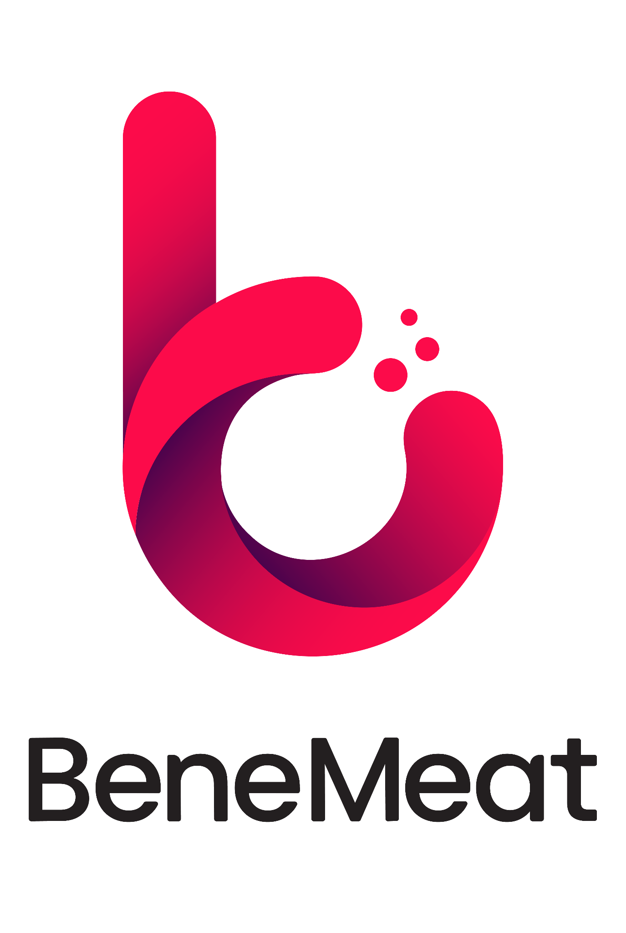

Your pets still have the chance to taste cultivated meat. BeneMeat’s Try & Share program continues across the EU.
Prague | 9. 12. 2025
The European Try & Share program, launched by BeneMeat at the end of September 2025, is still underway and is bringing its first results. The program allows dog owners from all over the EU to test dog treats rich in cultivated meat and share their experiences. People and their dogs from 25 European countries have joined the program so far, and current data shows that cultivated meat is quickly gaining popularity among the four-legged participants.
According to the responses so far, 90% of dog owners confirm that their pets liked the treats. Overall positive feedback from participants has reached 98%, and even 98.6% stated that they would participate again. The answers to whether people would buy the treats if they were commonly available are similarly optimistic, 85% of respondents answered yes.
For owners, however, it is not only about the taste of their dogs but also the values that cultivated meat represents. For 79.7% of participants, it is essential that the meat contains no antibiotics or hormones, and for 91%, animal welfare — an ethical, slaughter-free method of production, also plays an important role. These factors are proving to be key motivations for why people are joining Try & Share. Other reasons remain the desire to try something new and the growing interest in ethical and more sustainable forms of pet nutrition. The program shows that cultivated products are no longer just a curiosity but are becoming a real new option for consumers.
“The results confirm that cultivated meat has its place in pet food. People appreciate not only the taste of the treats but especially the ethics and the transparent way in which they are produced. This is an important step toward the broad acceptance of cultivated products. Try & Share allows us to collect long-term and valuable feedback from real users. This helps us further improve cultivated products and at the same time opens the door to a constructive debate about their importance for the future of pet nutrition,” says Jan Luprich, Strategic Partnerships Lead, BeneMeat.

The consumer survey also revealed the most common criticism, which is the size of the treats. Since the current size is uniform, owners of small dogs found it too large, and owners of large dogs found it too small. This result was expected, and BeneMeat jokingly comments on it as “the only problem that managed to unite both small and large dogs.”
The Try & Share program is still ongoing until December 31, 2025, and participants from across the European Union can still register via the page tryandshare.benemeat.com. Participation in the program is free of charge. Bene Meat will publish the complete results of the program after its conclusion.

Cultivated meat
Cultivated meat, also known as cultured meat or cell-based meat, is real animal meat produced by directly growing animal cells in a controlled environment instead of raising and slaughtering animals. The process begins with a small sample of animal cells, which are nourished with essential nutrients and guided to form muscle, fat, and connective tissue, replicating natural biological growth. The result is meat that is biologically identical to conventional meat but can be produced more sustainably, with lower environmental impact and improved animal welfare. A term Cultivated meat refers to meat (including muscle cells, fat cells, connective tissue, blood, and other components) produced by cultivating animal cells, not by slaughtering a live animal. (Source: New Harvest – a research institute that aims to accelerate progress in cellular agriculture).
BeneMeat
BeneMeat is a biotech company, part of the BTL Group, focused on developing scalable and efficient cultivated meat production technology. Since 2020, the company has developed deep, end-to-end expertise across biology, chemistry, hardware, software, and commercial implementation of cultivated meat. With 100+ R&D experts, BeneMeat is building the complete technological ecosystem, from versatile cell line development to scalable, reliable, and cost-effective manufacturing solutions. The company is prepared to support manufacturers through all the key challenges of bringing cultivated meat to market: technical, legal, regulatory, and commercial. BeneMeat is the first in the EU to be registered as a producer of cultivated meat for pet food (Autumn 2023), proving our regulatory leadership in this space. “We are not just another company in cultivated meat, we are the technology partner shaping its future.”
For more information, contact: media@benemeat.com

