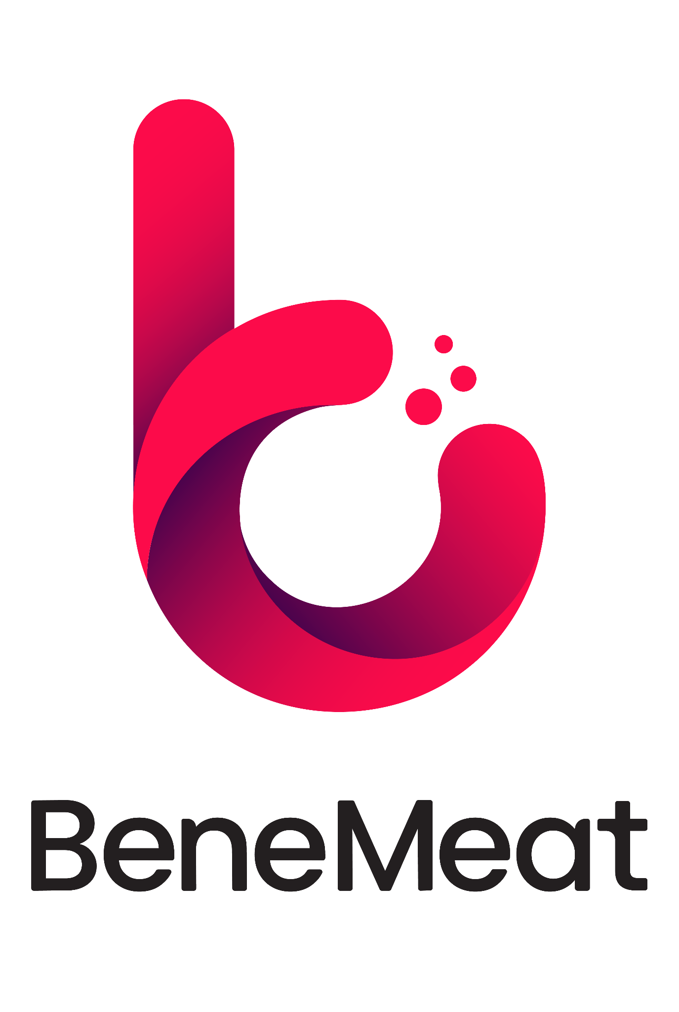

Britain’s Biotechnology Lead Should Not Be Negotiated Away
Czech company BeneMeat urges UK to retain regulatory autonomy on novel foods in open letter to the Prime Minister
Praha | 11. 09. 2026
Czech biotechnology company BeneMeat has written to the UK Prime Minister warning that uncertainty over the proposed UK–EU sanitary and phytosanitary (SPS) agreement is already causing companies to pause investment, partnerships and commercial plans in Britain.
In an open letter published today, BeneMeat argues that Britain has built a valuable lead in cultivated meat and related novel food technologies. It calls on the Government to ensure that any SPS agreement preserves the UK’s ability to assess and authorise new products according to its own scientific evidence, priorities and timetable.
“Britain has built an environment that attracts technology, know-how and investment,” said Roman Kříž, CEO BeneMeat. “If it gives up the ability to make decisions on emerging food technologies based on its own scientific evidence, priorities and timetable, it could quickly lose this advantage. Cooperation with the EU should make trade easier, it should not prevent Britain from deciding for itself how safe innovation can be developed and commercialised.”
As SPS negotiations have progressed, it has become clear that questions around the treatment of novel foods are already affecting the practical pathway for bringing cell-cultivated products into the UK for research and development. Companies that have prepared prototypes and controlled R&D activities are among the first to experience this uncertainty in practice, leaving concrete plans on hold.
BeneMeat stresses that cultivated meat is an early commercial application of cell-culture and bioprocessing technologies. The same foundational capabilities in large-scale biological manufacturing also strengthen a country’s broader knowledge and industrial base.
“The agreement has not yet been concluded, but the uncertainty surrounding Britain’s future regulatory approach is already affecting business decisions,” said Roman Kříž. “Companies need to know whether Britain intends to remain a place where emerging food biotechnologies can be developed and commercialised. Without that clarity, investment, partnerships and expertise will move elsewhere.”
BeneMeat, a spin-off of the medical technology group BTL Industries, has invested in the UK, established a presence and taken concrete steps towards bringing its technology to the British market. Further progress is now on hold while clarity is awaited.
The company is calling on the UK Government to ensure that any future SPS agreement preserves Britain’s autonomy in the regulation of novel foods and emerging food technologies.
The full open letter is available here:
https://www.benemeat.com/wp-content/uploads/2026/09/Open-Letter-to-Prime-Minister.pdf

Cultivated meat
Cultivated meat, also known as cultured meat or cell-based meat, is real animal meat produced by directly growing animal cells in a controlled environment instead of raising and slaughtering animals. The process begins with a small sample of animal cells, which are nourished with essential nutrients and guided to form muscle, fat, and connective tissue, replicating natural biological growth. The result is meat that is biologically identical to conventional meat but can be produced more sustainably, with lower environmental impact and improved animal welfare. A term Cultivated meat refers to meat (including muscle cells, fat cells, connective tissue, blood, and other components) produced by cultivating animal cells, not by slaughtering a live animal. (Source: New Harvest – a research institute that aims to accelerate progress in cellular agriculture).
www.benemeat.com
BeneMeat
BeneMeat is a biotech company, part of the BTL Group, focused on developing scalable and efficient cultivated meat production technology. Since 2020, the company has developed deep, end-to-end expertise across biology, chemistry, hardware, software, and commercial implementation of cultivated meat. With 150+ R&D experts, BeneMeat is building the complete technological ecosystem, from versatile cell line development to scalable, reliable, and cost-effective manufacturing solutions. The company is prepared to support manufacturers through all the key challenges of bringing cultivated meat to market: technical, legal, regulatory, and commercial. BeneMeat is the first in the EU to be registered as a producer of cultivated meat for pet food (Autumn 2023), proving our regulatory leadership in this space. “We are not just another company in cultivated meat, we are the technology partner shaping its future.”
For more information, contact: media@benemeat.com

